GDC Learning & Collaboration Events
Background to the Global Distributors Collective
- The GDC is a collective of 140+ last mile distribution companies around the world.
- The GDC supports and represents last mile distribution companies to help them reach underserved customers with household products that contribute to the Sustainable Development Goals. Its mission is to help make life-changing products affordable and available to all.
- The GDC provides a collective voice for distributors to ensure their voice is heard; drives research and innovation across the sector; facilitates the exchange of information, insight and expertise; and provides critical services that leverage economies of scale.
- The GDC is funded by DFID, P4G and IBAN/GIZ.

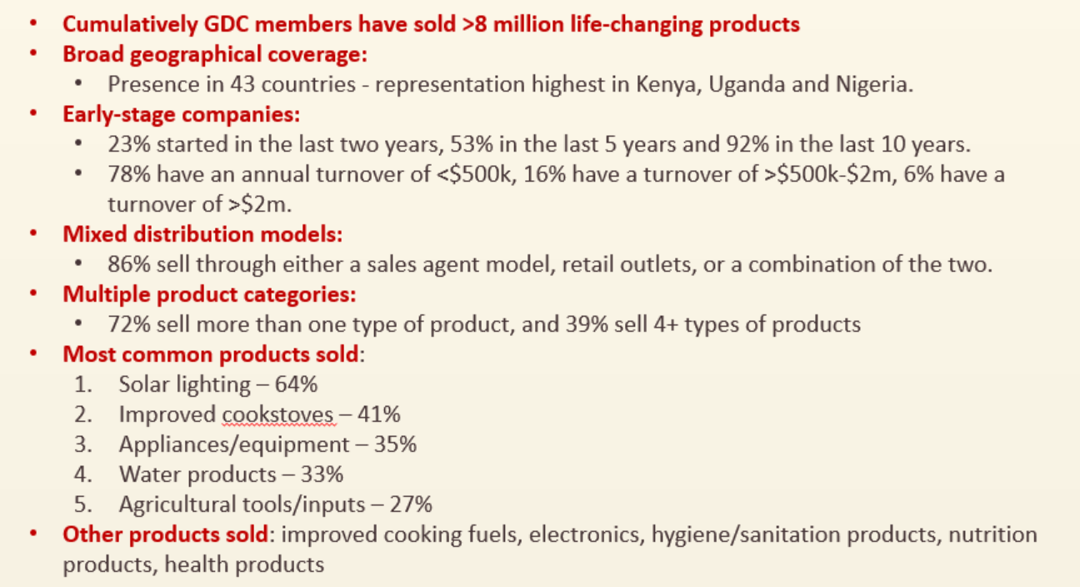
Snapshot of GDC membership

See the following page for examples of GDC members.

GDC learning & collaboration events – an overview
- The GDC will be holding a series of learning and collaboration events over the next two years across East/Southern Africa.
- The purpose of these events is to create more opportunities for GDC members, last mile distribution companies (LMDs), to come together to collaborate, network and share knowledge. The desired outcome is enhanced business performance of GDC members, e.g. through adoption of specific business practices or new business partnerships.
- We are designing these events based on extensive consultation with members, and have done a survey asking members what they would value most. Members indicated they are most interested in peer-to-peer learning, training from experts and match-making.

First event – Kampala, July 2019
- Location: Kampala, Uganda
- Date: 2 days over week starting 22 July (exact dates TBC but likely 22/23 July)
- Attendees: This first event is closed to GDC members only. We will invite all 140+ members and are expecting 30-40 to attend (with two representatives per member welcome). We have over 30 members in Uganda alone, and more tha1n 80 across the broader East Africa region (Uganda, Kenya, Tanzania, Rwanda, and Ethiopia).
  - Members in Uganda include companies such as WANA Energy Solutions, Pesitho, Anuel Energy, Africa Clean Energy, EnVenture, Potential Energy, Sistemo.bio, Village Energy and New Cares.
  - Members in Kenya include companies such as Mwezi, Livelyhoods, Pawame, Mukuru Clean Stoves and Bidhaa Sasa.

Draft agenda
Day 1
Agenda | Activity
9.00-9.30 | ARRIVAL AND REGISTRATION
9.30-11.00 | Welcome, introductions, asks & offers
11.00-11.30 | COFFEE BREAK
11.30-13.00pm | BOOTCAMPS WITH ‘GOLD-STANDARD’ LMDs  - (3x10 mins) Three ‘gold standard’ LMDs present on their business model, a challenge they have faced and an innovative way they have solved it. Focus areas likely to include sales staff management and retention, fundraising and marketing tools.  - (40 mins) LMDs split into three groups to work on one challenge with a ‘gold standard’ LMD and exchange insights and strategies  - (3x5mins) Groups present back what they have learnt and different ideas.  - 5 min closing
13.00-14.30pm | LUNCH & NETWORKING
14.30- 16.00pm | MINI ACADEMIES WITH MILLER CENTRE EXPERTS  - 3x30 min sessions rotating tables  - Miller Center experts facilitate table discussions in three priority areas and share expertise. Priority areas likely to include consumer financing, investment readiness and logistics.  - Participants discuss opportunities and challenges
16.00- 16.30pm | COFFEE BREAK
16.30-17.30pm | Present and Discuss Winning Innovations from the GDC’s Innovation Challenge
17.30-19.30 | Drinks Reception and Informal Networking
Day 2
Agenda | Activity
9.00-9.30 | ARRIVAL & COFFEE
9.30-11.30 | ACCESSING FINANCE AND PREPARING FOR INVESTMENT  Series of interactive presentations with plenary Q&A:  - 1-2 presentations from donors/investors on what they look for in funding partners, eg. Africa Enterprise Challenge Fund, SIMA Funds, D-Prize  - 1-2 presentations from experts eg. VentureBuilder on what LMDs need to be investment ready, in terms of processes, documentation and systems
11.30-12.00 | COFFEE BREAK
12.00-13.00 | EVENT CLOSING
13.00-14.00 | LUNCH
14.00-18.00 | OPTIONAL SITE VISIT

