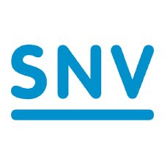
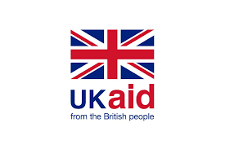
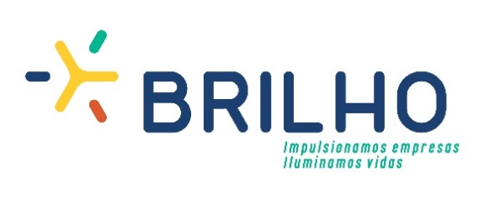

1st Call for applications is open
Market Development Fund – BRILHO Mozambique

Invitation for Submission of Expressions of Interest

BRILHO is a 5 year programme, funded by UK Department for International Development (DFID) and implemented by SNV Netherlands Development Organisation, which aims to accelerate the off-grid market in Mozambique, promoting and supporting businesses initiatives that can provide clean and accessible energy solutions to the population and enterprises.

BRILHO’s mandate is to support private sector initiatives by leveraging its capacity for innovation and resources to develop and invest in off-grid solutions and services; and thus improve the lives of people through savings, well-being and livelihood opportunities, while providing commercial benefits for the private sector.

To achieve its objective, BRILHO’s Market Development Fund offers to selected businesses a mix of non-reimbursable funding for up to £ 1,500,000 per company and specialised technical support, to de-risk business initiatives that aim to achieve competitive commercial returns. Alongside this, BRILHO supports the sector ecosystem development by improving access to information, stimulating demand, setting quality benchmarks and advocating for a better regulatory framework.
Do you have a business initiative in the off-grid energy sector?

You may be eligible to receive BRILHO support
For more information, contact us: support@brilhomoz.com
www.BrilhoMoz.com

